Website orders
A paid website order runs from checkout through a posted invoice on its own. Each step below is marked Automatic or By hand. Do not email the invoice.

1. The order is confirmed
Automatic. When the customer pays, the order becomes a Sales Order. You do not confirm it. The website emails the order confirmation. Leave Send alone.
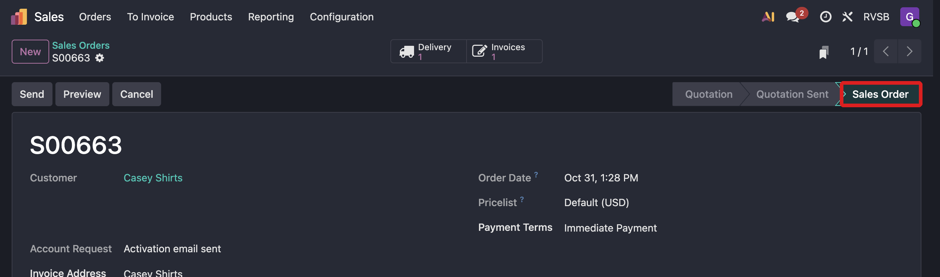
Automatic. The status is already Sales Order.

2. The invoice is posted
Automatic. The invoice is created and posted, and the website payment is on it. The customer is not emailed the invoice. Leave Send alone. Leave Reset to Draft alone.
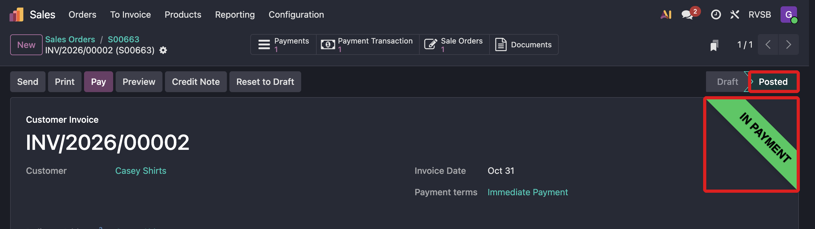
Automatic. The invoice is Posted, and the ribbon says In Payment.

3. Create Invoice is still on the order
By hand. A zero-dollar order, or an order that was never paid on the site, does not get that invoice. It stays under Sales → To Invoice.
Click Create Invoice and create the draft. Open the invoice and click Confirm. That posts it. If the customer has paid, click Pay. Leave Send alone.
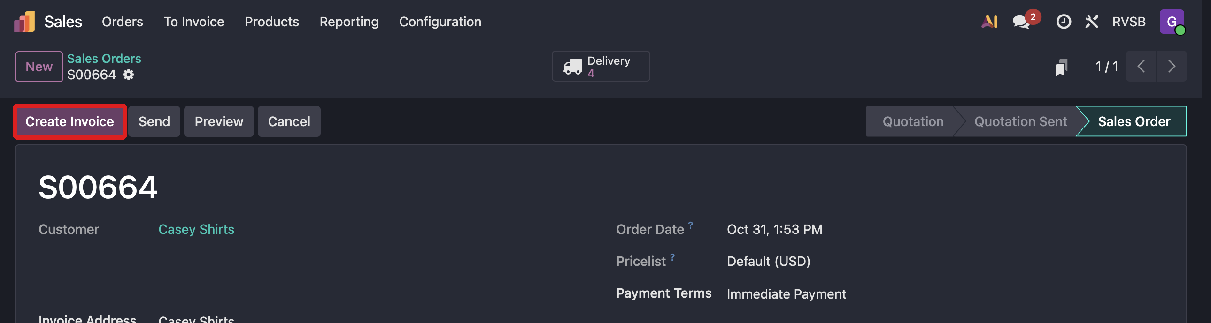
By hand. Create Invoice is still in the header.

4. Shipping
Automatic. When the cart had both warehouse stock and later stock, the customer already chose one of these at checkout:
- Ship what's in stock now, and the rest within 7–10 days.
- Hold the order and ship everything together.

Shipping was charged once for the whole order.
By hand. Picking and the label are in the pick and ship SOP. Do the in-stock pick now. The later pick waits until the Victron order is received.

5. Units the warehouse does not have
Automatic. Those units are added to one draft Victron purchase order. Sales orders share that draft until someone confirms it. Casey gets the to-do Finish PO and send to Victron.
By hand. Open the purchase order, check the quantity and the price, and confirm Victron can still fill it. Then confirm the purchase order. Nothing is sent to Victron until that confirmation.
If the chatter on the sales order says the purchase order was not created, set the Victron vendor under Inventory → Settings → Victron E-Order, then create the RFQ by hand.

